When exploring linear growth, we observed a constant rate of change. For example, in the equation $f\left(x\right)=3x+4$ , the slope tells us the output increases by 3 each time the input increases by 1. Exponential functions are different because we have a constant percent change per unit time (rather than a constant change).

# Identifying Exponential Functions

Let’s contrast exponential growth with linear growth.

| $$x$$ | $$f\left(x\right)=2^{x}$$ (exponential growth) | $$g\left(x\right)=2x$$ (linear growth) |
| --- | --- | --- |
| 0 | 1 | 0 |
| 1 | 2 | 2 |
| 2 | 4 | 4 |
| 3 | 8 | 6 |
| 4 | 16 | 8 |
| 5 | 32 | 10 |
| 6 | 64 | 12 |

From looking at the table, we can see that exponential growth increases much faster than linear growth. The difference between “the same percentage” and “the same amount” is quite significant. For exponential growth, over equal increments, the constant multiplicative rate of change resulted in doubling the output whenever the input increased by one. For linear growth, the constant additive rate of change over equal increments resulted in adding 2 to the output whenever the input was increased by one.

The general form of the exponential function is

$f\left(x\right)=ab^{x}$

where

$a$ is any nonzero number and is considered the initial or starting value of the function.

$b$ is a positive real number not equal to 1 and is considered the growth/decay factor.

If $b>1$ , the function grows at a rate proportional to its size. **Exponential growth**refers to an *increase* based on a constant multiplicative rate of change over equal increments of time, that is, a *percent* increase of the original amount over time.

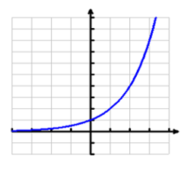

If $0<b<1$ , the function decays at a rate proportional to its size. **Exponential decay** refers to a decrease based on a constant multiplicative rate of change over equal increments of time, that is, a percent decrease of the original amount over time.

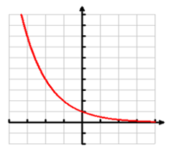

Examples:

1. For each of the following, identify whether the statement represents an exponential function or a linear function.
   1. The average annual population increase of a pack of wolves is 25.
   2. A population of bacteria decreases by a factor of 18 every 24 hours.
   3. The value of a coin collection has increased by 3.25% annually over the last 20 years.
   4. For each training session, a personal trainer charges his clients $5 less than the previous training session.
2. Identify whether the exponential function is a growth or a decay function and determine the initial value.
$f\left(x\right)=3{\left(1.8\right)}^{x}$

$g\left(x\right)=2.1{\left(0.4\right)}^{x}$

3. Which of the following equations are not exponential functions?

$f\left(x\right)=4^{3\left(x-2\right)}$

$g\left(x\right)=x^{3}$

$h\left(x\right)={\left(\frac{1}{3}\right)}^{x}$

$j\left(x\right)={\left(-2\right)}^{x}$

# Graphs of Exponential Functions

We should be able to graph exponential functions and identify key characteristics.

For any real number $x$ , an exponential function is a function with the form

$$f\left(x\right)=ab^{x}$$

The domain of $f$  is all real numbers.

The range of $f$  is all positive real numbers if $a>0$ .

The range of $f$ is all negative real numbers if $a<0$ .

The $y$ -intercept is $(0, a)$ and the horizontal asymptote is $y=0$ .

Example: Below is the graph of the function, $f\left(x\right)=2^{x}$. Using the graph, find the key characteristics.

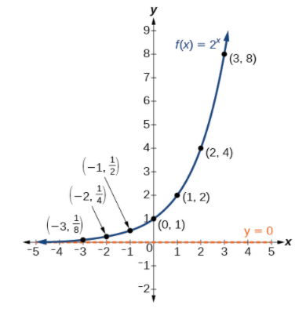

Domain:

Range:

As $x→∞, f(x)→$

As $x→-∞, f(x)→$

Horizontal asymptote:

$x$-intercept:

$y$-intercept:

# Evaluating Exponential Functions

To evaluate an exponential function, substitute $x$ with the given value, and calculate the resulting power.

Examples

1. Let $f\left(x\right)=5{\left(3\right)}^{x+1}$.
   1. Find $f\left(-3\right).$
   2. Find $f\left(2\right).$
   3. Find $f\left(0\right).$
2. The population of India was about 1.25 billion in the year 2013, with an annual growth rate of about 1.2%. This situation is represented by the growth function $P\left(t\right)=1.25{\left(1.012\right)}^{t}$, where $t$ is the number of years since 2013. To the nearest thousandth, what will the population of India be in 2031?

# Finding Equations of Exponential Functions

**Given two data points**, we can write an exponential model by

If one of the data points has the form $(0,a)$, then $a$ is the initial value. Using $a$, substitute the second point into the equation $f\left(x\right)=ab^{x}$, and solve for $b$.

If neither of the data points have the form $(0,a)$, substitute both points into two equations with the form $f\left(x\right)=a{\left(b\right)}^{x}$. Solve the resulting system of two equations in two unknowns to find $a$ and $b$.

Using the $a$ and $b$ found in the steps above, write the exponential function in the form $f\left(x\right)=a{\left(b\right)}^{x}$.

Examples

1. Find an exponential function that passes through the points $(-2, 6)$ and $(2, 1)$.
2. In 2006, 80 deer were introduced into a wildlife refuge. By 2012, the population had grown to 180 deer. The population was growing exponentially. Write an exponential function $N(t)$ representing the population $N$ of deer over time $t$.

Given the graph of an exponential function, we can write its equation by using the steps above.

First, identify two points on the graph. Choose the $y$-intercept as one of the two points whenever possible. Try to choose points that are as far apart as possible to reduce round-off

Write the exponential function in the form $f\left(x\right)=a{\left(b\right)}^{x}$.

Example: Find an equation for the exponential function below.

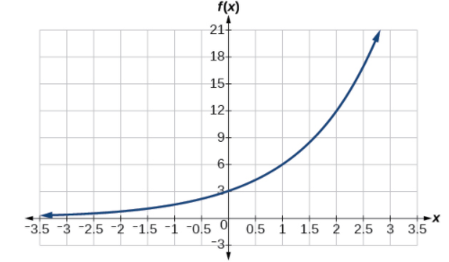

# Applying the Compound-Interest Formula

Savings instruments in which earnings are continually reinvested, such as mutual funds and retirement accounts, use compound interest. The term compounding refers to interest earned not only on the original value, but on the accumulated value of the account.

Compound interest can be calculated using the formula

$$A\left(t\right)=P{\left(1+\frac{r}{n}\right)}^{nt}$$

where

$A(t)$ is the account value

$t$ is measured in years

$P$ is the starting amount of the account, often called the principal

$r$ is the annual percentage rate (APR) expressed as a decimal

$n$ is the number of compounding periods in one year

Here is a list of common compounding frequencies:

| Frequency | $n$ value |
| --- | --- |
| Annually | 1 |
| Semiannually | 2 |
| Quarterly | 4 |
| Monthly | 12 |
| Daily | 365 |

Examples

1. If we invest $3,000 in an investment account paying 3% interest compounded quarterly, how much will the account be worth in 10 years?
2. A 529 Plan is a college-savings plan that allows relatives to invest money to pay for a child’s future college tuition; the account grows tax-free. Lily wants to set up a 529 account for her new granddaughter and wants the account to grow to $40,000 over 18 years. She believes the account will earn 6% compounded semi-annually. To the nearest dollar, how much will Lily need to invest in the account right now?

# Evaluating Functions with Base e

The number $e$ represents the irrational number

${\left(1+\frac{1}{n}\right)}^{n}$, as $n$ increases without bound

The letter $e$ is used as a base for many real-world exponential models. To work with base $e$, we use the approximation, $e≈2.718282$.

Example: Calculate $e^{3.14}$. Round to five decimal places.

# Investigating Continuous Growth

For many real-world phenomena, $e$  is used as the base for exponential functions. Exponential models that use $e$  as the base are called continuous growth or decay models. We see these models in finance, computer science, and most of the sciences, such as physics, toxicology, and fluid dynamics.

For all real numbers $t$ , and all positive numbers $a$   and $r$ , continuous growth or decay is represented by the formula

$$A\left(t\right)=ae^{rt}$$

where

$a$ is the initial value,

$r$ is the continuous growth rate per unit time,

and $t$  is the elapsed time.

If $r>0$ , then the formula represents continuous growth. If $r<0$ , then the formula represents continuous decay.

For business applications, the continuous growth formula is called the continuous compounding formula and takes the form

$$A\left(t\right)=Pe^{rt}$$

where

$P$ is the principal or the initial invested,

$r$ is the growth or interest rate per unit time,

and $t$   is the period or term of the investment.

Examples

1. A person invested $1,000 in an account earning a nominal 10% per year compounded continuously. How much was in the account at the end of one year?
2. Radon-222 decays at a continuous rate of 17.3% per day. How much will 100 mg of Radon-222 decay to in 3 days?